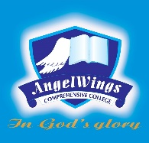

|  |  |
| --- | --- |
| **ANGELWINGS COMPREHENSIVE COLLEGE, MAROKO, PW, KUBWA, ABUJA** | |
| **SECOND TERM EXAMINATION 2024/2025 ACADEMIC SESSION** | |
| **SUBJECT: National Values** | **CLASS: GRADE THREE** |

1. What is the meaning of "Nigeria soit beni"? _______________  
  
2. Translate "My mouth" to French _______________  
  
3. What is the French word for "Mes cheveux"? _______________  
  
4. Translate "Qu'est-ce que TU aimes" to English _______________  
  
5. Fill in the blank: geria ne te _______________